Standard Operating Procedure for:  Moving gas cylinders | PPE required:      
Introduction
Gas cylinders themselves pose manual handling and pressure related risks. They may also pose a risk depending on the contents of the cylinder. Operators should understand the properties of gases they handle, the potential hazards and emergency actions. All persons moving gas cylinders must have the correct PPE including steel toe capped boots, chemical and impact resistant safety glasses, and rigger gloves.
Cylinder should always be properly secured. Never tamper with cylinders in any way: for example repaint cylinder change markings of ID, or interfere with threads. Any damage should be reported. Never try to operate a cylinder in the gas cage. New and expectant mothers should not carry out this task.
Transporting cylinders  Before cylinders are transported remove any gas regulators or other connections from the cylinder. See Changing Regulators SOP for this. Ensure you are wearing appropriate PPE (see above).  - Check cylinder for any damage before moving it and check it is the type of gas you want.  - Replace any valve guard caps if available before transporting cylinders.  - Transport of cylinders should be done using a trolley - check trolley is in good condition. Where this is not possible milk churning is acceptable for short distances on level ground (<5m). Cylinders should always be transported in an upright position with valves closed.  - When using a cylinder trolley ensure the cylinder is properly located and secured.  - It is forbidden to accompany gas cylinders in the lift. You must display a notice forbidding entry prominently, so that people do not enter the lift at intermediate floors. Never attempt to transport cylinders via the stairs.  - If the cylinder falls do not attempt to catch it, just get out of the way and fetch a technician to help you pick it up.  - If leaving an empty cylinder in the gas cage make sure it is marked appropriately as empty (marked ‘MT’ in white chalk).  - Make sure that the gas cage is locked after use and that all items are recorded in and out.  Fire procedure  Gas cylinders may explode if involved in a fire; therefore, on discovering fire follow University procedure:  - Raise the alarm using fire points and call security on 32222 (0113 343 2222) giving the location of the fire, the location of any trapped persons, the type of fire i.e. the type of fuel involved, report any hazardous substances involved, name of gases, location and numbers of cylinders.  - Evacuate the building following standard University procedure.  - If an acetylene cylinder has been involved in a fire the fire brigade should be contacted (even if closing the valve extinguishes the fire).  - If it is possible to safely remove cylinders not directly involved in the fire to a safe place do so only if there is no undue risk. Ensure you follow the procedure above. IF IN DOUBT, GET OUT.  - No attempt should be made to move or operate gas cylinders that has been involved in a fire or close to one even if it appears to be cold. Contact a technician before operating gas cylinders. | Hazard symbols:  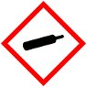  Others depending on gas – see MSDS
Gases covered
air, argon, carbon dioxide, helium, hydrogen, methane, nitrous oxide, nitrogen, nitrogen (5% hydrogen), oxygen, xenon
Acetylene (see extra notes)
Significant hazards:
- High pressure
- Low oxygen levels
- Toxic gases
- Heavy weight
Hazard phrases (H):
H220, H270, H280
Can it be done out of hours?
Gas cylinders should never be transported out of hours.
This SOP is not relevant in the following circumstances:
- Where gas cylinders contain gases other than those listed above (e.g. CO, SO₂, F₂, H₂S).
- SOP does not cover specific experimental risk - these must be covered by user’s assessments.
- Any other situation where the procedure may result in harm to yourself or others.

Standard Operating Procedure for:  Changing regulators | PPE required:
Introduction
Operators should understand the properties of gases they handle, the potential hazards and emergency actions. All persons changing or operating regulators must have the correct PPE including chemical and impact resistant safety glasses. Never use oil or PTFE tape on regulator – cylinder valve thread (or on any thread if gas is oxygen).
Turning off the gas  Ensure that the cylinder is securely positioned in workplace before removing regulator. Check that it is safe to turn the gas off and that it will not damage any equipment. Ensure you are wearing appropriate PPE (see above).  - Turn off at the cylinder valve, if possible and safely depressurise the regulator.  - Close (fully back off) the pressure adjusting screw on the regulator.  Remove the gas regulator  Ideally the regulator should be depressurised (emptied of gas) before removal if this is possible (see above).  - Remove the regulator with the appropriate spanner – not an adjustable one – ask a technician if you find this difficult.  - If transporting the regulator replace any protection caps to prevent contamination.  Attaching a regulator  - Ensure that the cylinder is securely positioned in workplace before regulator and equipment is connected.  - If it is a new cylinder remove the disposable seal and anything else blocking the outlet and hand wheel valve.  - Check for grease or oil in cylinder valve. If found do not use – return to supplier.  - Check for dirt or water in the outlet valve. If so clean using a lint free cloth or compressed air (do not open the cylinder valve to clean the valve).  - Make sure that the type of regulator matches the type of gas in the gas cylinder.  - Make sure that the regulator has an input pressure that is suitable for the cylinder and an output pressure suitable for the application with a maximum output not significantly higher than the desired pressure.  - Check that the regulator is within manufacture and inspection date, if not, do not use.  - Check the regulator for any damage, and check that the needles on the gauges start at zero. Speak to a technician if you suspect any damage to the regulator.  - Place the regulator into the valve and using fingers, then the spanner, to turn the hexagonal nut. Normally turn clockwise. Or anti clockwise for fuel gases. Use reasonable, not excessive, force until tight.  Turning on gas  - Check that it is safe to turn on the gas for equipment and people.  - With the regulator correctly attached to the cylinder ensure that the pressure adjusting screw is fully backed off and closed.  - Slowly open the cylinder valve with the correct spindle key or hand wheel (fully and then turn back one half turn), and check that the contents gauge on the regulator goes up. Do not remove the spindle key if used.  - Set the required outlet pressure by carefully adjusting the pressure adjusting screw.  - Once system is pressurized check for leaks, either a suitable leak detection solution or pressure drop test (see relevant SOP) | Hazard symbols:  Others depending on gas – see MSDS
Gases covered
air, argon, carbon dioxide, helium, methane, nitrogen, nitrogen (5% hydrogen), oxygen, xenon
Acetylene (see extra notes)
Significant hazards:
- High pressure
- Low oxygen levels
- Toxic gases
- Heavy weight
Hazard phrases (H):
H220, H270, H280
Can it be done out of hours?

Gas cylinder regulators can be operated out of hours but should not be changed unless specific permission has been received.
This SOP is not relevant in the following circumstances:
- Where gas cylinders contain gases other than those listed above (e.g. CO, SO₂, F₂, H₂S).
- SOP does not cover specific experimental risk these must be covered by user’s assessments
- Any other situation where the procedure may result in harm to yourself or others.

Standard Operating Procedure for:  Leak detection | PPE required:
Introduction
Operators should understand the properties of gases they handle, the potential hazards and emergency actions. All persons changing or operating regulators must have the correct PPE including chemical and impact resistant safety glasses.
Once system is pressurised check for leaks, either a suitable leak detection solution or pressure drop test.
Leak detection – using fluid  Use some leak detection fluid (detergent) to check for leaks. If detergent is not appropriate deionized water can be used put pressure drop test is preferable. Never use soapy water as oils in soaps may lead to an explosion.  - Check that it is safe to turn the gas on/off and that it will not damage any equipment.  - With the regulator correctly attached to the cylinder ensure that the pressure adjusting screw is fully backed off and closed.  - Slowly open the cylinder valve fully and then turn back one half turn  - Apply approved leak detection solution to the cylinder valve connection and regulator inlet, outlet and gauge connections and hose outlet.  - If no bubbles occur then once the equipment beyond the regulator has been checked the system is safe to use.  - If bubbles occur turn off the cylinder valve and depressurize the regulator.  - Remove regulator and check threads, if damaged replace the regulator and notify lab staff of faulty regulator (See Changing Regulators SOP).  - If the hose assembly is found to be leaking the whole assembly should be replaced.  - Return to Step 1 using only moderate, never excessive force to attach the regulator.  - If after repeated efforts you are still finding a leak talk to lab staff.  Leak detection - Pressure drop test  - Check that it is safe to turn the gas off and that it will not damage any equipment.  - With the regulator correctly attached to the cylinder (see relevant SOP) ensure that the pressure adjusting screw is fully backed off and closed.  - Slowly open the cylinder valve  - Observe and record the contents gauge reading  - Turn off the cylinder valve  - Watch the contents gauge for one minute or longer noting any fall in pressure reading  - If a fall in pressure is observed then a leak is present.  - Safely depressurise the system  - Remove the regulator and check threads  - If damaged replace the regulator and notify lab staff of faulty regulator.  - Return to step 1.  If a leak persists  - Separate cylinder to be removed by supplier as soon as possible  - Never attempt to use PTFE or jointing compounds to rectify the problem. | Hazard symbols:  Others depending on gas – see MSDS
Gases covered
air, argon, carbon dioxide, helium, methane, nitrogen, nitrogen (5% hydrogen), oxygen, xenon
Acetylene (see extra notes)
Significant hazards:
- High pressure
- Low oxygen levels
- Toxic gases
- Heavy weight
Hazard phrases (H):
H220, H270, H280
Can it be done out of hours?

Gas cylinder regulators can be operated out of hours but should not be changed unless specific permission has been received.

This SOP is not relevant in the following circumstances:
- Where gas cylinders contain gases other than that list above (e.g. CO, SO₂, F₂, H₂S)
- SOP does not cover specific experimental risk these must be covered by user’s assessments
- Any other situation where the procedure may result in harm to yourself or others.

Standard Operating Procedure for:  Acetylene cylinder notes | PPE required:
Introduction
This SOP should be used in conjunction with SOPs for Moving Gas Cylinders, Changing Regulators, risk and COSHH assessments.

If there is a fire external, but close to, the acetylene cylinder please follow SOP for Moving Gas Cylinders if safe to do so.
Moving acetylene cylinders  - Acetylene cylinders should only be moved by trained personnel and the amount of movement should be kept to a minimum. Do not excessively churn acetylene cylinders.  - Prior to moving a cylinder check it’s temperature with the back of a bare hand. (See notes below of cylinder is warm)  - Never move or approach an acetylene cylinder that has been in a fire or subject to severe heat or shock, or if it is found on its side.  - Allow 20mins settling time after a cylinder has been moved before connecting to the manifold.  - Treat an empty cylinder the same way a full cylinder would be treated.  If cylinder is found to be warming, do not move or touch  - Evacuate the building and sound the fire alarm.  - Call security 32222 (0113 3432222 if using a mobile) and inform them of the situation and that the fire brigade are required. If the security is unavailable call 9-999.  - Inform Jerry Lee as fire marshal and local fire wardens.  - Inform BOC on 0800111333, our account number is 1400860.  Accidental release measures  Leak not ignited:  - Extinguish all ignition sources.  - Check cylinder is not getting hot using back of bare hand.  - Check valve is properly closer use only moderate force (hand tight).  - DO NOT try to tighten cylinder valve in the body of the cylinder or tamper with the safety devices.  If leak persists:  - Evacuate personnel from the area.  - Ensure maximum ventilation, if outside warn everyone in the area of gas leak.  - Inform security and BOC as above.  Leak ignited (cylinder not getting hot):  - Extinguish all ignition sources.  - Extinguish the flame with foam or water only if it is safe to do so.  - Wear leather gauntlets and keep hands clear of fusible plugs.  - Close cylinder valve and check cylinder for signs of heating. | Hazard symbols:  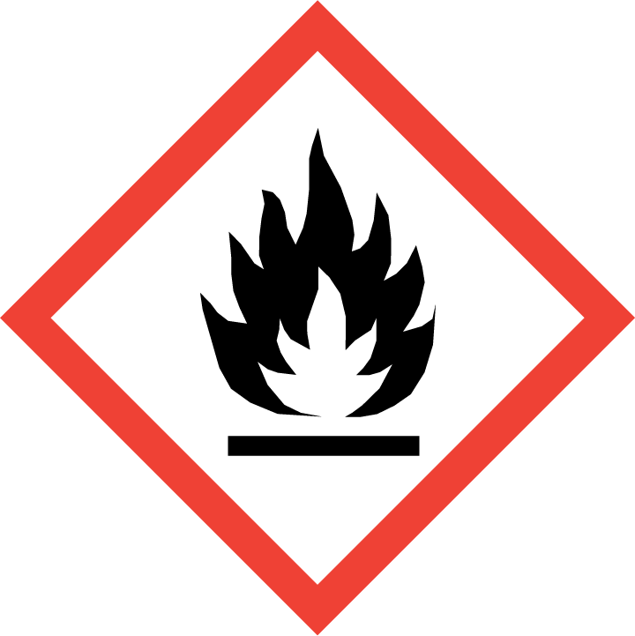
Gases covered
Acetylene
Significant hazards:
- High pressure
- Low oxygen levels
- Toxic gases
- Heavy weight
Hazard phrases (H):
H220, H280
Can it be done out of hours?

Acetylene cylinders should never be handled out of hours.
This SOP is not relevant in the following circumstances:
- SOP does not cover specific experimental risk these must be covered by user’s assessments
- Any other situation where the procedure may result in harm to yourself or others.

